Docker Exercise

Reference documentation | Docker Documentation

Build, ship and run any application, anywhere.
Docker uses a client/server architecture:
the docker client talks to
a docker daemon via sockets or a RESTful API.
Docker is a client-server application.
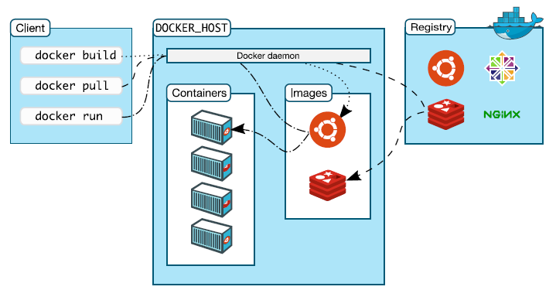
The Docker daemon
Receives and processes incoming Docker API requests.
The Docker client
Talks to the Docker daemon via the Docker API. We'll use mostly the CLI embedded within the docker binary
Docker Hub Registry
Collection of public images. The Docker daemon talks to it via the registry API. (https://hub/docker.com)
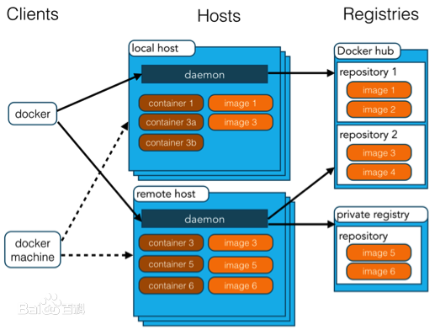

Our First Containers
In your Docker environment, just run the following command:
$ docker run busybox echo hello world
hello world

That was our first container!
We used one of the smallest, simplest images available: busybox.
busybox is typically used in embedded systems (phones, routers...)
We ran a single process and echo'ed hello world.

You should got similar result:
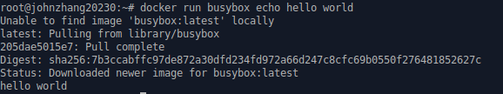
You can also fetch a docker image from the docker registry first, and then run it.
docker pull busybox
docker run busybox echo hello world

A more useful container
Let's run a more exciting container:
$ docker run -it ubuntu bash
This is a brand new container.
It runs an ubuntu system.
-it is shorthand for -i -t.
-i tells Docker to connect us to the container's stdin.
-t tells Docker that we want a pseudo-terminal.
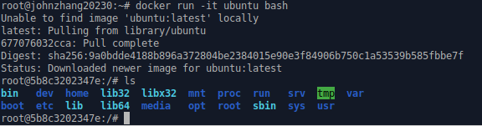
Find out docker images you have in your machine:
docker images
Find out how many containers running:
docker ps
To start/stop/restart a container:
docker start [option] <containerID>
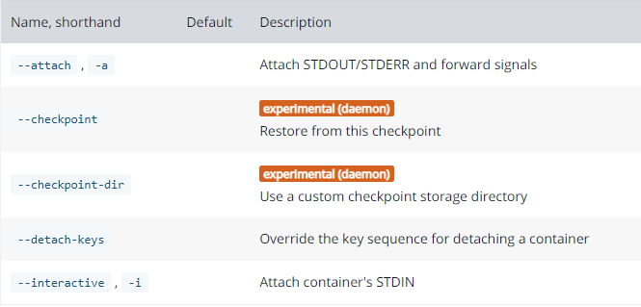
docker stop <containerID>
docker restart < containerID>
To exit the docker container, Type command:
exit

Do something in our container
Try to run figlet in our container.

root@5e5d04140a14:/# figlet hello
bash: figlet: command not found
Alright, we need to install it.
We want figlet, so let's install it on this container:
root@5e5d04140a14:/# apt update
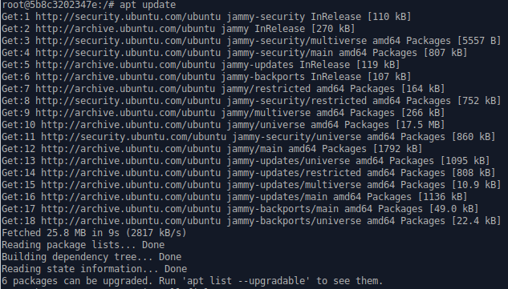

root@5e5d04140a14:/# apt install figlet
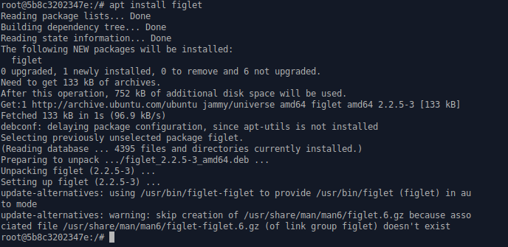
A few minutes later, figlet is installed! (It depends on the quality of your network connection)
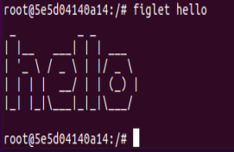

root@5e5d04140a14:/# figlet hello
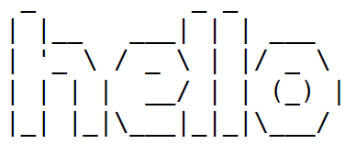

Exiting our container
Just exit the shell, like you would usually do.
root@5e5d04140a14:/# exit
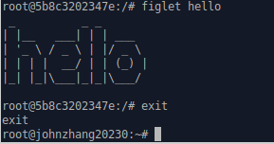
Our container is now in a stopped state.
It still exists on disk, but all compute resources have been freed up.

When you install figlet, you may encounter some errors, such as cannot find the server. Here is one solution, that is, replace Ubuntu pks source with Aliyun. Here are steps on how to change the source to Aliyun:

Step1: find sources.list in /etc/apt
cd /etc/apt
ls
You will find the file sources.list. We are going to edit this file!
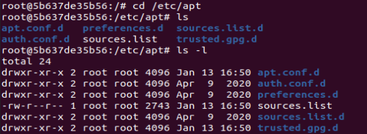
Step2: modify this file with the following contents
In docker version ubuntu, there is no vi,
you can install vim instead:
apt install vim
then use vim to edit this file. The usage is almost the same as vi.
Double click d can delete a line, click x delete one char.
Delete all the old contents.

Type i to enter the insert mode, type a to enter append mode.
Type Esc to back to command mode. Only command mode can move your mouse.

Insert the following lines to the file:

deb http://mirrors.aliyun.com/ubuntu/ xenial main restricted universe multiverse
deb http://mirrors.aliyun.com/ubuntu/ xenial-security main restricted universe multiverse
deb http://mirrors.aliyun.com/ubuntu/ xenial-updates main restricted universe multiverse
deb http://mirrors.aliyun.com/ubuntu/ xenial-backports main restricted universe multiverse
deb-src http://mirrors.aliyun.com/ubuntu/ xenial main restricted universe multiverse
deb-src http://mirrors.aliyun.com/ubuntu/ xenial-security main restricted universe multiverse
deb-src http://mirrors.aliyun.com/ubuntu/ xenial-updates main restricted universe multiverse
deb-src http://mirrors.aliyun.com/ubuntu/ xenial-backports main restricted universe multiverse

Press Esc to switch to command mode.

Save the new content:
:wq
Press enter to save the file

Step3: Enable the changes:
apt update
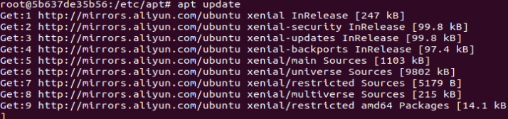
Step 4: Install figlet.
apt-get install figlet
or
apt install figlet
These two commands are almost the same.
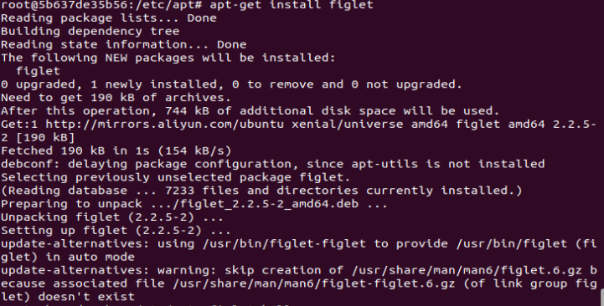

Step 5: run figlet
figlet hello

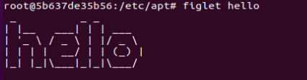

Starting another container
What if we start a new container, and try to run figlet again?
$ docker run -it ubuntu bash
root@35d361fe1161:/# figlet
bash: figlet: command not found
We started a brand new container.
The basic Ubuntu image was used, and figlet is not here.
exit the bash.

root@35d361fe1161:/# exit
exit
$

Let's check that our running containers：
$ docker ps

List All containers, including stopped ones
We can also see stopped containers, with the -a (--all) option.
$ docker ps -a

This is what I have in my machine:
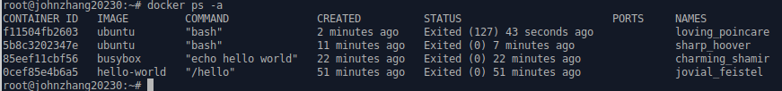
Restarting a container
When a container has exited, it is in stopped state.
It can then be restarted with the start command.

$ docker start <yourContainerID>
The container will be restarted using the same options you launched it with.
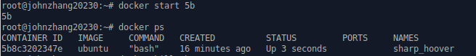
Now, I want to kill it. Type the following command:
$docker kill 5b

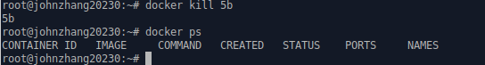

Warning!!!
You may get an error when killing a container sometime.
You have to do aa-remove-unknown first in order to kill this container.
$sudo aa-remove-unknown
Now you can do kill again
$docker kill 5b
The container is killed successfully.

Understanding Docker Images
What is an image?
An image is a collection of files + some metadata.
(Technically: those files form the root filesystem of a container.)
Images are made of layers, conceptually stacked on top of each other.
Each layer can add, change, and remove files.
Images can share layers to optimize disk usage, transfer times, and memory use.

Differences between containers and images
An image is a read-only filesystem.
A container is an encapsulated set of processes running in a read-write copy of that filesystem.
To optimize container boot time, copy-on-write is used instead of regular copy.

docker run starts a container from a given image.

Images are conceptually similar to classes.
Layers are conceptually similar to inheritance.
Containers are conceptually similar to instances.

If an image is read-only, how do we change it?
We don't.
We create a new container from that image.
Then we make changes to that container.

If we are satisfied with those changes, we transform them into a new layer. A new image is created by stacking the new layer on top of the old image.

Creating other images
docker commit
Saves all the changes made to a container into a new layer.
Creates a new image (effectively a copy of the container).
docker build
create a new image using Dockerfile
Performs a repeatable build sequence.

This is the preferred method!

How do you store and manage images?
Images can be stored:
- On your Docker host.
- In a Docker registry.

You can use the Docker client to download (pull) or upload (push) images. To be more accurate: you can use the Docker client to tell a Docker server to push and pull images to and from a registry.

Showing current images
Let's look at what images are on our host now.
$ docker images
It shows what you have on your ubuntu.
Here is my docker images:
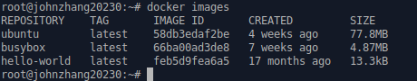

Searching for images
Searches your registry for images:
$ docker search zookeeper

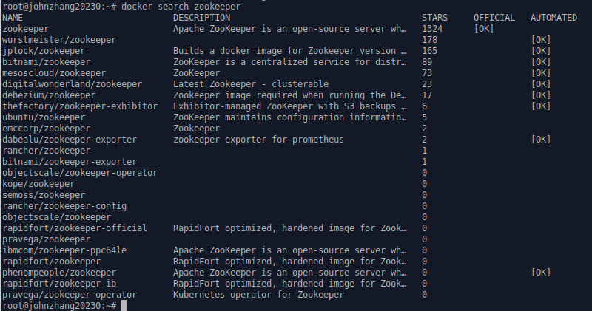

Downloading images
There are two ways to download images.
- Explicitly, with docker pull.
- Implicitly, when executing docker run and the image is not found locally.

Pulling an image
$ docker pull debian:jessie
Pulling repository debian
b164861940b8: Download complete
b164861940b8: Pulling image (jessie) from debian
d1881793a057: Download complete

Images are made up of layers.
Docker has downloaded all the necessary layers.
In this example, :jessie indicates which exact version of Debian we would like.
It is a version tag.

Image and tags
Images can have tags.
Tags define image versions or variants.
docker pull ubuntu will refer to ubuntu:latest.
The :latest tag is generally updated often.

Building Images Interactively

As we have seen, the images on the Docker Hub are sometimes very basic. How do we want to construct our own images?
As an example, we will build an image that has figlet. First, we will do it manually with docker commit.

Building from a base
Our base will be the ubuntu image.
Start an Ubuntu container:
$ docker run -it ubuntu bash
root@<yourContainerId>:/#
Run the command apt update to refresh the list of packages available to install.
Then run the command apt install figlet to install the program we are interested in.

root@<yourContainerId>:/# apt update && apt install figlet
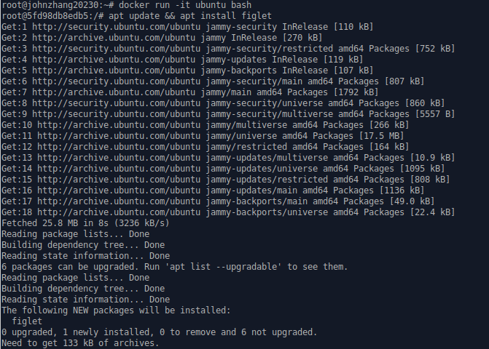
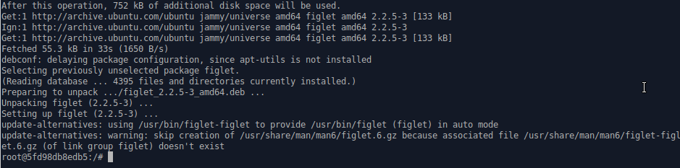
Inspect the changes
Type exit at the container prompt to leave the interactive session.
Type docker ps -a to find out container IDs

Let's run docker diff to see the difference between the base image and our container just created

$ docker diff <yourContainerId>
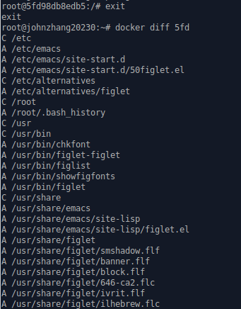

Symbol | Description
A | A file or directory was added
D | A file or directory was deleted
C | A file or directory was changed

Docker tracks filesystem changes
As explained before:
- An image is read-only.
- When we make changes, they happen in a copy of the image.
- Docker can show the difference between the image, and its copy.
- For performance, Docker uses copy-on-write systems.
(i.e. starting a container based on a big image doesn't incur a huge copy.)

Commit and run your image
Before we commit, let’s check our current images:

$ docker images

The docker commit command will create a new layer with those changes, and a new image using this new layer.

$ docker commit <yourContainerId>

Let’s check images we have now:

$ docker images

The new image is created.

The output of the docker commit command will be the ID for your newly created image.
We can run this image:
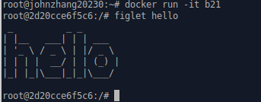

Tagging images
Referring to an image by its ID is not convenient. Let's tag it instead.
First, type exit to stop the container.
Then, we can use the tag command to add a tag for this image:

$ docker tag <newImageId> figlet

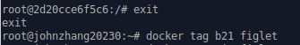

But we can also specify the tag as an extra argument to commit:
$ docker commit <containerId> figlet

And then run it using its tag:
$ docker run -it figlet
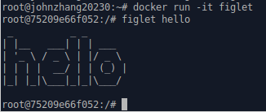

Building Images With A Dockerfile
Dockerfile overview
- A Dockerfile is a build recipe for a Docker image.
- It contains a series of instructions telling Docker how an image is constructed.
- The docker build command builds an image from a Dockerfile.

Writing our first Dockerfile

Our Dockerfile must be in a new, empty directory.
Create a directory to hold our Dockerfile.
$ mkdir myimage
Create a Dockerfile inside this directory.
$ cd myimage
$ vi Dockerfile
Type this into our Dockerfile...

FROM ubuntu
RUN apt update
RUN apt install figlet

FROM indicates the base image for our build.
Each RUN line will be executed by Docker during the build.
Our RUN commands must be non-interactive.
(No input can be provided to Docker during the build.)

Save our file, then execute:

$ docker build -t figlet .

-t indicates the tag to apply to the image.
. indicates the location of the build context.

The output of docker build looks like this:
$ docker build -t figlet .

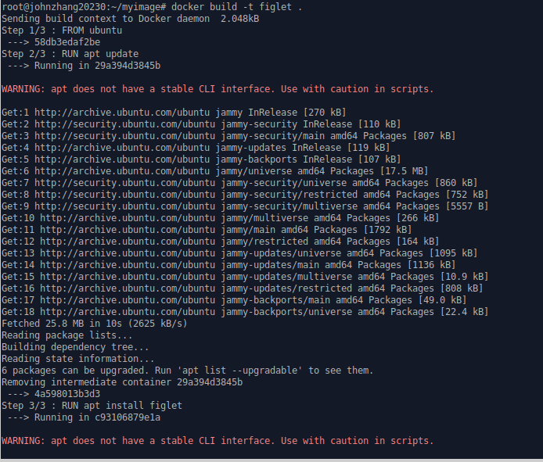
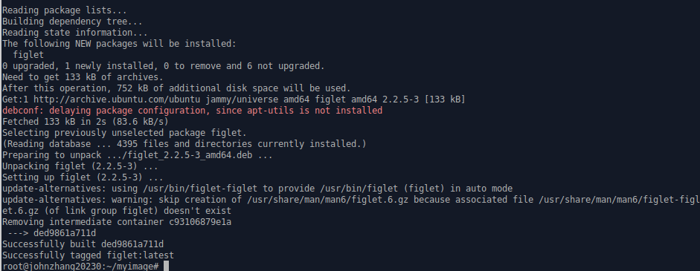

Running the image
$ docker run -it figlet
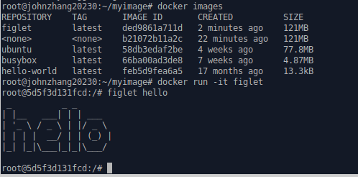

The resulting image is not different from the one produced manually.

Copying files during the build
Build some C code
We want to build a container that compiles a basic "Hello world" program in C.
Here is the program, hello.c:
int main () {
puts("Hello, world!");
return 0;
}

Let's create a new directory:
mkdir newimage
and put this file in there.
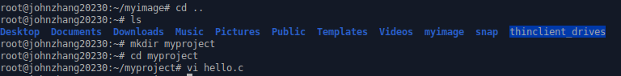

Then we will write the Dockerfile for it.

FROM ubuntu
RUN apt update
RUN apt-get install -y build-essential
COPY hello.c /
RUN make hello
CMD /hello

On Debian and Ubuntu, the package build-essential will get us a compiler.
When installing it, don't forget to specify the -y flag, otherwise the build will fail (since the build cannot be interactive).
Then we will use COPY to place the source file into the container.
Create this Dockerfile.

Testing our C program
- Create hello.c and Dockerfile in the same direcotry.
- Run docker build -t hello . in this directory.
- Run docker run hello, you should see Hello, world!.
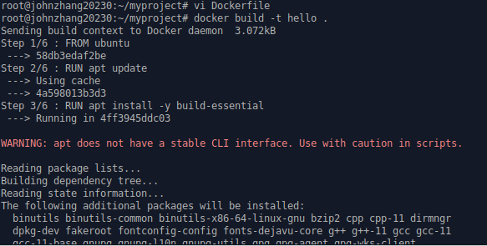
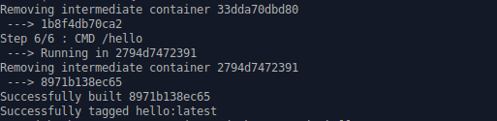
You can check that a new image (hello) is created:

$ docker images

Run the image hello:
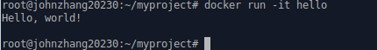

Naming our containers
Default names
When we create a container, if we don't give a specific name, Docker will pick one for us.
It will be the concatenation of:
- A mood (furious, goofy, suspicious, boring...)
- The name of a famous inventor (tesla, darwin, wozniak...)
Examples: happy_curie, clever_hopper, jovial_lovelace ...

Specifying a name
You can set the name of the container when you create it.
$ docker run --name ticktock jpetazzo/clock
If you specify a name that already exists, Docker will refuse to create the container. This lets us enforce unicity of a given resource.

Renaming containers
Since Docker 1.5 (released February 2015), you can rename containers with docker rename.

Inspecting a container
The docker inspect command will output a very detailed JSON map.
$ docker inspect <containerID>
[{
"AppArmorProfile": "",
"Args": [],
"Config": {
"AttachStderr": true,
"AttachStdin": false,
"AttachStdout": true,
"Cmd": [
"bash"
],
"CpuShares": 0,
...

Container Networking Basics

A simple, static web server
Run the Docker Hub image nginx, which contains a basic web server:
$ docker run -d -P nginx

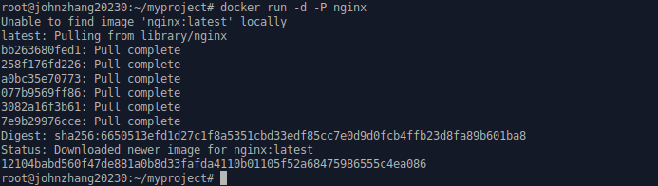

Docker will download the image from the Docker Hub.
- -d tells Docker to run the image in the background.
- -P tells Docker to make this service reachable from other computers.
(-P is the short version of --publish-all.)
But, how do we connect to our web server now?

Finding our web server port
We will use docker ps:
$ docker ps

- The web server is running on ports 80 inside the container.
- Those ports are mapped to ports 49153 on our docker host. (On your machine, it may be different)

Connecting to our web server (GUI)
Point your browser to the IP address of your Docker host, on the port shown by docker ps for container port 80.

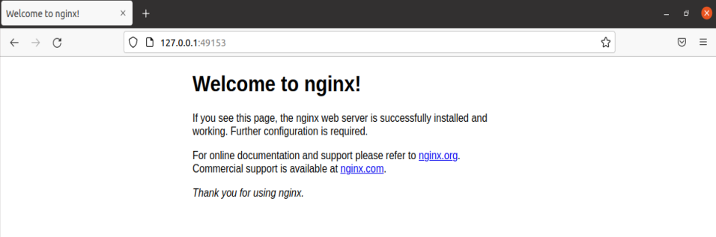

Connecting to our web server (CLI)
You can also use curl directly from the Docker host.
Make sure to use the right port number if it is different from the example below:
$ curl localhost:49153

But you have to install curl first.
$sudo snap install curl
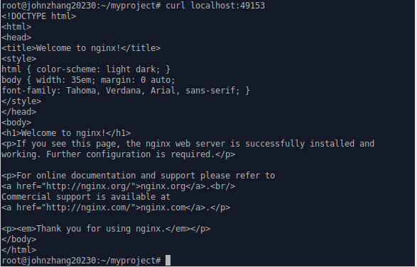

Why are we mapping ports?
- We are out of IPv4 addresses.
- Containers cannot have public IPv4 addresses.
- They have private addresses.
- Services have to be exposed port by port.
- Ports have to be mapped to avoid conflicts.

Finding the webserver port in a script
Parsing the output of docker ps would be painful.
There is a command to help us:
$ docker port <containerID> 80
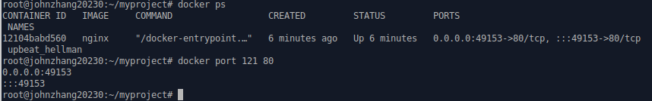

Manual allocation of port numbers
If you want to set port numbers yourself, no problem:
$ docker run -d -p 80:80 nginx
$ docker run -d -p 8000:80 nginx
- We are running two NGINX web servers.
- The first one is exposed on port 80.
- The second one is exposed on port 8000.

Note: the convention is port-on-host:port-on-container.

Plumbing containers into your infrastructure
There are (at least) three ways to integrate containers in your network.
- Start the container, letting Docker allocate a public port for it.
Then retrieve that port number and feed it to your configuration.
- Pick a fixed port number in advance, when you generate your configuration. Then start your container by setting the port numbers manually.
- Use an overlay network, connecting your containers with e.g. VLANs, tunnels...

Finding the container's IP address
We can use the docker inspect command to find the IP address of the container.
$ docker inspect --format ‘{{.NetworkSettings.IPAddress}}’ <containerID>

docker inspect is an advanced command, that can retrieve a ton of information about our containers. Here, we provide it with a format string to extract exactly the private IP address of the container.

Pinging our container
We can test connectivity to the container using the IP address we've just discovered.
Let's see this now by using the ping tool.
$ ping <ipAddress>
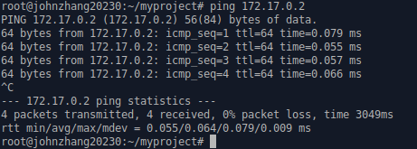

Docker now has the notion of a network, and a new top-level command to manipulate and see those networks: docker network.

$ docker network ls

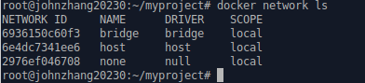

What's in a network?
Conceptually, a network is a virtual switch.
It can be local (to a single Engine) or global (across multiple hosts).
A network has an IP subnet associated with it.
A network is managed by a driver.
A network can have a custom IPAM (IP allocator).
Containers with explicit names are discoverable via DNS.
All the drivers that we have seen before are available.
A new multi-host driver, overlay, is available.
More drivers can be provided by plugins (OVS, VLAN...)

Creating a network
Let's create a network

$ docker network create skynet

The network is now visible with the network ls command:

$ docker network ls
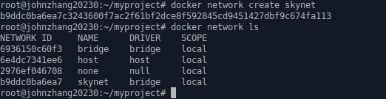

Deleting a network
$ docker network rm <newtworkID>



